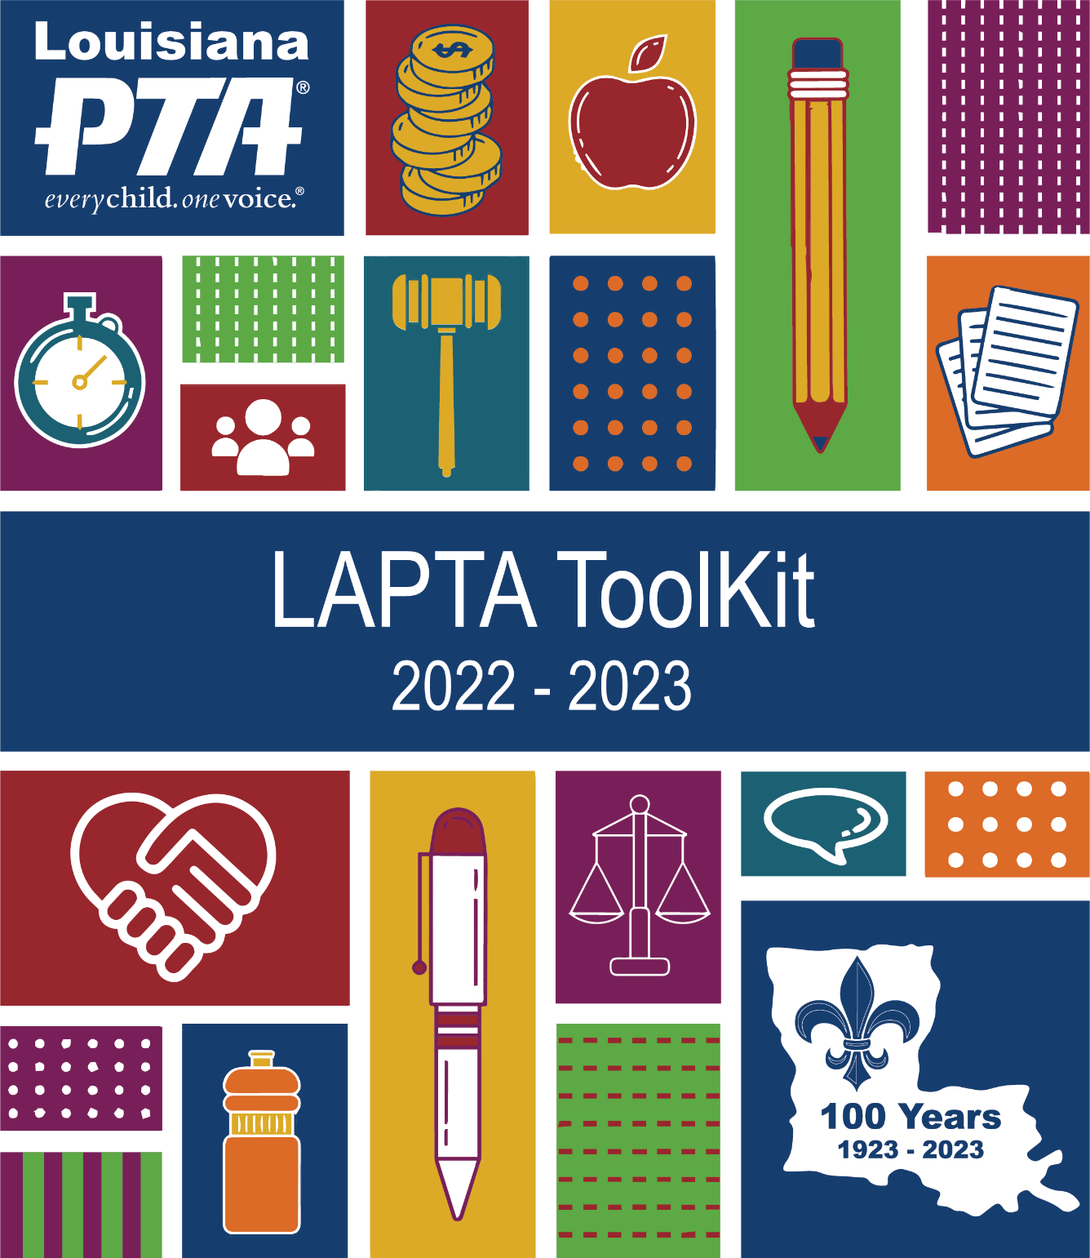

Louisiana PTA Toolkit
2022 – 2023
LouisianaPTA.org

INDEX
Louisiana PTA Office and PTA Basics, Section 1

Louisiana PTA Office 3
What does LAPTA Do? 3
LAPTA Board of Directors 4
LAPTA Dates and Deadlines 5
About National PTA 7
Procedure Binder & Email Protocol 8
Customize the PTA logo 8
Communications and Social Media 9
CheddarUp and MoneyMinder 11
What is Active Affiliation 12
Retention Plan 12
Reactivation Phase 12
Active Affiliation Report 13
Active Affiliation: Plan of Action 14

President, Section 2

About National PTA 3
Leadership Traits 4
Important Document and Terms 4
Essential Knowledge 5
Important Dates and Deadlines 6
Getting Started 8
Building Your Board of Directors 9
Pick Your PTA Programs 10
PTA Leadership Training by LAPTA 10
Finances 11
CheddarUp.com and MoneyMinder.com 12
Communications and Social Media 13
Membership 15
Centennial Button for Members 15
Customize the PTA Logo 15
Meeting Types 15
Elements of Successful Meetings 16
Agendas 17
Parliamentary Law 18
Problem Solving 19
President’s Duties Checklist 20
Dos and Don’ts of Partnering with Administrators 22
Dos and Don’ts of Partnering with Teachers 23
President’s Binder 24
Sample Passwords and Accounts Summary 24
Fundraising Strategies 25
Year-End Checklist and Transition Guidance 26
Inventory Accountability Form 27
What is Active Affiliation? 28
Retention Plan 28
Reactivation Phase 28
Active Affiliation Report 29
Active Affiliation: Plan of Action 30
Icebreakers 31
Sample Agenda 32
Sample Meeting Script 33
Confidentiality, Ethics, and Conflict of Interest Policy 37

Treasurer, Section 3

Introduction 4
Responsibilities of the Treasurer 5
Treasurer’s Binder 5
Principles of PTA Financial Management 6
Budget 7
Banking and E-Commerce Policy 9
CheddarUp and MoneyMinder 12
Record Keeping & Retention 13
Articles of Incorporation 13
Reports 14
Raising Money 14
Insurance and Bonding 15
Audit Committee and Report 16
Federal Taxes 17
Sales Tax 19
Gifts to Schools 20
Additional Resources 20
Communications and Social Media 21
What is Active Affiliation? 23
Retention Plan 23
Reactivation Phase 23
Active Affiliation Report 24
Active Affiliation: Plan of Action 25
Inventory Accountability Form 26
Treasurer’s Overview Checklist 27
Budget Approval Form 28
Sample Budgets and Comparison Reports 29
Year-End Financial Checklist 31
Deposit Form 32
Expense Form 33
Bylaws and Amendments Approval Form 34
Audit Report Form 35
Audit Procedures and Helpful Hints 36
Audit Worksheet 37
Sample Letter for NSF Check 38
PTA Monetary Donation to a School or District 39
Equipment Purchased by a PTA for Its Use 40
Donation Receipt 41
Passwords and Accounts Summary 42
Confidentiality, Ethics, and Conflict of Interest Policy 43

Secretary, Section 4

Importance of Secretary 4
Dates and Deadlines 5
Responsibilities of Secretary 7
Historian 8
Minutes 9
Motions and Elections 10
Content of Minutes 10
Records Retention 12
Secretary’s Binder 12
Customize the PTA Logo 12
Communications and Social Media 13
Sample Agenda 15
Sample Minutes 16
Motion Form 17
Roster Sign-In Sheet 18
Confidentiality, Ethics, and Conflict of Interest Policy 19
What is Active Affiliation? 21
Retention Plan 21
Reactivation Phase 21
Active Affiliation Report 22
Active Affiliation: Plan of Action Form 23
Inventory Accountability Form 24

Board of Directors, Section 5

Dates and Deadlines 4
Being a Board of Directors Member 6
Quorum 7
Importance of Boardsmanship 7
Getting Started 8
Executive Committee 9
Committees 9
Committee Examples 9
Orientation Meeting 12
Virtual Meetings 12
Setting Goals 12
Finance for Board Members 13
How Boards Succeed 14
PTA Leadership Training 15
Procedure Binder 15
Communications and Social Media 17
PTA FAQs 18
Dos and Don’ts of Partnering with Administrators 19
Dos and Don’ts of Partnering with Teachers 20
Confidentiality, Ethics, and Conflict of Interest Policy 21
Bylaws Approval Form 23
Inventory Accountability Form 24
What is Active Affiliation? 25
Retention Plan 25
Reactivation Phase 25
Active Affiliation Report 26
Active Affiliation: Plan of Action Form 27

Membership, Section 6

Introduction 4
Membership Campaign Theme 5
Membership Dues 5
Membership Resources & 9 Reasons to Join 6
Create Your Own PTA Value Message 7
Getting Started 10
Membership Chair Duties 10
Membership Ask Note or Email 11
Procedure Binder 11
Monthly Challenges 12
Annual Membership Awards 12
Centennial Button Pins 12
Membership Graphics 13
Submit Membership Dues 14
CheddarUp and MoneyMinder 15
Membership Calendar 16
LAPTA Important Dates and Deadlines 18
Why You Should PTA 20
Communications and Social Media 21
Customize the PTA Logo 23
Membership Hashtag and Email Signature 23
Sample Membership Ask Email 23
Sample Membership Ask Note 24
Sample Membership Thank You Email 25
Sample Membership Thank You Note 25
Roster Sign-In Sheet 26

Advocacy, Section 7

Introduction to Advocacy 4
Gateway to Advocacy: Why Advocate? 5
Advocating on an Issue: Planning 6
Advocacy Strategy Chart 6
Setting Goals 7
Raising Public Awareness 7
Conducting Candidate or Issue Forums 8
Forum Timeline 10
Implementation: Developing Your Message 11
The Voice of Membership 12
Using the Media 13
How to Write a Press Release 14
Sample Thank You Letter to Legislator 14
Advocating with Your School Board 15
Communications and Social Media 16
Advocacy Award for Local PTA Units 18
Advocacy Awards for Students 19

Diversity, Equity, and Inclusion (DEI), Section 8

Introduction 4
Promote Diversity in Your School 5
Hold an Inclusive PTA Meeting 6
Organize and Inclusive PTA Event 7
Icebreakers 8
DEI Resources 9
Communications and Social Media 10

Elections and Nominating Committee, Section 9

Nominating Committee 3
Elections 4
Script for Non-Contested Elections 5
Script for Contested Elections 6
Nominating Committee Report 7
Teller Committee Report 8
Confidentiality, Ethics, and Conflict of Interest Policy 9

Bylaws, Standing Rules, and Articles of Incorporation, Section 10

Bylaws & Amendments: Updating & Approval 3
Bylaws and Amendments Approval Form 4
Instructions for Bylaws Template 5
Standing Rules 7
Articles of Incorporation 8

Awards, Grants, and Contests, Section 11

Monthly Membership Challenges 3
Annual Membership Awards 3
Centennial Button Pins 3
Safety Poster Contest & Sample Flyer 4
Love Louisiana Video Challenge & Sample Flyer 6
Reflections Theme Search Contest 8
Reflections Program 9
Outstanding PTA Newsletter Award 10
Advocacy Award for Local PTA Units 11
Advocacy Award for Students 12
Volunteer of the Year Award 13
Mentor-a-PTA Award 14
Apply for National PTA Grants 15
Top Grant Writing Tips 15
Louisiana PTA Grants Overview 16
$750 Reading & Literacy Grant Application 17
$750 Healthy Minds Grant Application 18
$500 LAPTA Day of Service Grant Application 19
$500 Creative Teacher Grant Application 20
$75 National PTA Legislative Convention Grant 21
$75 National PTA Convention Grant Application 22

