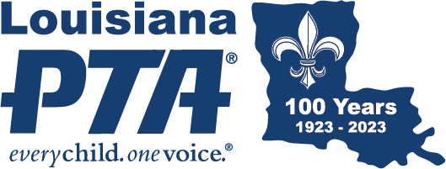
MEMBERSHIP
CAMPAIGN THEME
Visit PTA.org and select Membership Resources under the “Run Your PTA” menu where you can find graphics, resources, and support documentation. While a Local PTA Unit can choose their own annual membership theme, National PTA chose a clear and concise phrase to motivate and recruit new members and reinforce the value of PTA membership. The membership theme is:
PTA For Your Child
This overarching message serves as the basis for all campaign messaging. PTA offers all parents and caregivers the opportunity to be engaged in their child's potential. Being a member of PTA means that you are part of a powerful association and action plan that focuses on programs and initiatives that strengthen your child's education and the family-school partnership. However you PTA, it's all an investment in your child. PTA to support your child's teachers and curriculum. PTA to advocate on the issues impacting your child and affect change at the local, state, and national levels. PTA to build a stronger, more diverse, and inclusive school community. There is no wrong way to PTA, and we invite every family to participate, because we can do more together than apart. How do you PTA?

PTA is no longer a noun. It's a verb, an action plan working to support your child's success! It's an invitation to every family in every school to participate, because we can do more together than we can do apart. There's no wrong way to PTA, just as long as you're doing it for your child. You can give money by joining and donating. You can volunteer time and effort. Or you can help grow our presence at the local, state, or national level as an advocate for improving your child's education.

