$500 LAPTA CREATIVE TEACHER
GRANT APPLICATION
Application Deadline: February 28, 2023 Apply at https://form.jotform.com/221796420623152
Winners Announced: March 25, 2023 Quantity Offered: 2

LAPTA offers Creative Teacher Grants to classroom teachers to fund creative, innovative, and fun programs or projects for students. Grants may fund instructional and classroom materials, videos, parent involvement programs, or any activity or material which supports student enjoyment, wonder, and engagement. Funds must be used between August 1, 2023, and May 31, 2024.

Proposal shall be clear and logical and include a specific objective; a creative or innovative approach; clear description of instructional procedures, methods, or treatments; and emphasis on student enjoyment, wonder, and excitement. The teacher or group of teachers must be a current PTA member at their school.

Our hope is that this grant will result in fun and enriching projects or opportunities for the students that would not otherwise have been possible.

The information needed for the online application is contact information, applicants who are current PTA members at their school, and name of proposed project, including:
- What will the project accomplish?
- Which and how many students will the project serve?
- How will the project specifically benefit the students?
- What is fun, creative, and innovative about the project?
- What are the complete details of the project?
- How will the project be publicized to parents, families, and the community before and after the project?
- Further support documentation or video uploads may be included to improve the application.

The applicant fully understands that if it receives this grant, the money shall not be used for other programs or activities except for those listed on this application form. A written evaluation of the efforts is due to submit@LouisianaPTA.org by June 30, 2024, unless an extension has been granted by the LAPTA President. The evaluation must contain all details pertaining to the use of the funds received under this grant including receipts of expenditures and any other supporting documentation. Failure to provide documentation requested as it pertains to this application may result in forfeiture of any or all grant funds and ineligibility of future grants.
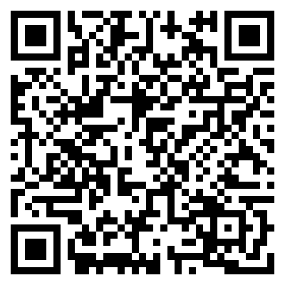
Applications must be submitted online at https://form.jotform.com/221796420623152 or scan the QR Code.

